Number Sense  Game: How to Play  1. Each person will take turns rolling the dice. Find the first number rolled on the 1st chart and record that number on paper.  2. Roll the dice again and find the second number on the 2nd chart. Record that number as well. j  3. Multiply the two numbers together.  4. Your partner will do the same thing.  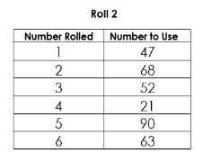  5. The player with the greatest product gets a point. The first person to get 6 points, wins!  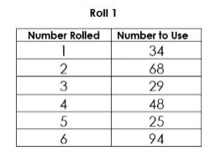 | Number Sense  Billy-Bob owns a candy store. He orders six hundred fifty-one jaw breakers. When they get delivered 5 days later, he wants to put an equal amount in seven see-through candy jars. How many jawbreakers go in each jar? Will there be more than 100 in each jar? | Number Sense  Order of Operations  In math, there is a very specific order in which you can complete an operation.  P – Parenthesis ( )  2 x (2+3)  2 x (5)  10  E – Exponents 5³  In 5³ the "3" says to use 5 three times in a multiplication,  so 5³ = 5 × 5 x 5 = 125  D - Division  M - Multiplication  A - Addition  S - Subtraction  Ex.  4^{3 + (4 – 2) x 3}  4^{3 + (2) x 3}  ^{64 + 2 x 3}  ⁶⁴ ⁺ ⁶  ⁷⁰  https://www.youtube.com/watch?v=ZzeDWFhYv3E  Try to find the answers to the following operations:  - 3 x 9 + 7  - (67 – 18) ÷ 7 x 3  - 5² - 8  - 2 x 11 – 12 ÷ 2  - (7 x 8 – 4) ÷ (6 – 2)
Statistics & Probability
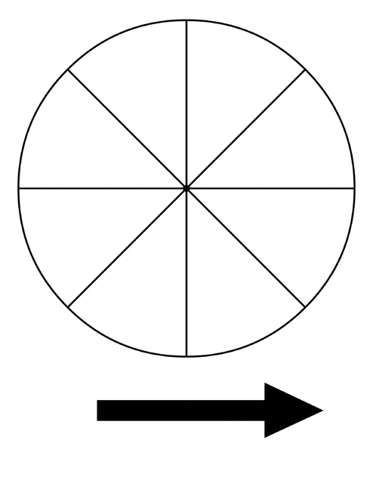
Design a spinner (printable templates can be found online) so that when the pointer is spun:
- Landing on red is most likely.
- Landing on blue is impossible.
- Landing on green and landing on yellow are equally likely.
- Landing on purple is least likely.
Explain your work.

Extension: Create a math board game that uses this spinner in it!
Math & Science  Measurement Mystery to identify an unknown object!  Click on this link: https://www.youtube.com/watch?v=7omxmCDpW7U and learn about how to determine what a thing is based on its quantitative or measurable properties.  Task: Have another member of your family give you the measurements of an object including (length, width, height, and weight). You can use a ruler and scale to give you an idea of what the object looks like. Try and guess what the object could be. If you have difficulty guessing what the object is, they can also give a qualitative description of that object looks like including its colour, texture. | Shape & Space  Metric system: units of distance  Click on this link Metric System: Units of distance to review metric units of length or distance such as millimeter, centimeter, meter, and kilometer.  Click here:  Practice estimating length to practice!
Math & Art
Watch this video as a review Identifying Transformations:

https://www.khanacademy.org/math/basic-geo/basic-geo-transformations-congruence/transformations-intro-basic-geo/v/identifying-transformations

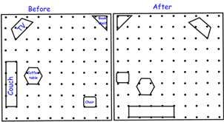

Vicki decided to reorganize her living room furniture. Above is a diagram of the changes she made:
Task: Identify all the transformations you see.
Patterns & Relations
Sam charges $6 for each hour he babysits.
How much does Sam earn when he works 2 hours? 4 hours? 5 hours? Show your results in a table.

What patterns do you see in the table? How is each term different from the term before? Use the patterns to predict how much Sam will earn working 21 hours.

Will Sam earn exactly $40? $45? $50? How do you know?

Sam saves all the money he earns. He needs $250 to buy a mountain bike. How many hours does Sam need to work?

Make up your own problem you can solve with this table.
Math Online
https://www.mathplayground.com/index_fractions.html

www.prodigy.com

https://www.mrnussbaum.com/placevaluepirates

