Writing  May is « National Bike Month ». If you could create a bicycle path through your neighborhood or through your town, where would the path lead? Would there be anything special on the path (picnic tables? Bird feeders?)? Include a description of the sights and sounds someone would see along your path. Even better, why not include a map of your path? Be sure to include a legend on your map! | Reading Comprehension  Main Idea  The main idea is what a text is mostly about. The main idea can be identified through titles, pictures, repeated ideas and words. It can also be explained in the first or last sentence of a paragraph.  Read over the four paragraphs in the attachment entitled “Main Idea” and determine the main idea for each one. Once finished, send your answers to your teacher or discuss them with a classmate. | Literacy & Art  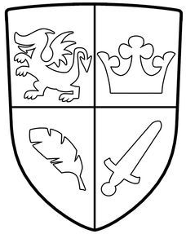  Use this knight shield as an example.  Task: Create your own coat of arms with images that represents you. Make sure you divide it in four sections. Include the things that make you happy like music, dancing, sports, games, food, family, and friends.  Write a paragraph explaining why you chose each image and how they represent you.
Literacy Project
(multi-day)
Invented your own cereal based on a fictional book they read.

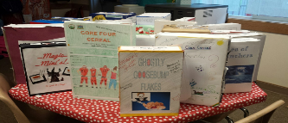

The cereal box is designed as follows:
Front: Name of cereal and a picture to go with it.
Back: Design a game that is based on the book.
Right side: “Ingredients,” list the main characters and a sentence about each one. Also includes the setting.
Left side: Summary of the book
Top: The title, Author of the book and students name.

 | Oral Communication (français)  Roule et Parle!  Fais un appel à un ami et jouer le jeu ‘Roule et Parle!’.  Un jeu idéal pour:  ✓se présenter  ✓ poser des questions  ✓s’amuser  *See attachment called ‘Roule et Parle’ for French game. | Science  How to Make Invisible Ink  Click on this link:  https://www.youtube.com/watch?v=RBFuVn6y_UI and learn how you can make your own invisible ink.  Task: Collect the ingredients indicated in this video and follow the steps to make the invisible ink. Write your secret message and have another family member find out what your message says.  Click on this link:  https://www.youtube.com/watch?v=pkpjF8kRqls to find out about The Science Behind Invisible Ink.
Creative Writing (English)
Listed below are the answers to unknown questions. You have to write a possible question to get such an answer! Good luck!
- The moon would explode!
- Chickens would rule the world.
- Everyone would carry a turtle in their pocket.
- The ocean would be purple.
- I would be rich.
- Skunks would smell like flowers.
- Candy would be illegal.
- Everyone would suddenly be 10 years older.
- Buses would fly.
- Harry Potter would be Prime Minister.
Personal Wellness (English)  Game: Keep It Moving  This game requires you to move pawns around the game board and it includes prompts for exercise. Directives such as Do 8 sit ups or Crab walk and sing the Alphabet Song get us moving! Let’s go!! ☺  **See attachment for game board! |  | Science  Identifying Simple Machines  https://www.youtube.com/watch?v=LSfNYpCprw4  Watch the video above and find examples of each of the 6 simple machines described from around your home!  Lever  Wheel and axle  Pulley  Inclined Plane  Wedge  Screw

