Writing  What is an idiom?  Idioms are everywhere! We use them so often and usually don’t even realize! If your friends or family tell you that it’s raining cats and dogs, you probably would put on your rain boots and a rain jacket if you were going outside.  “An idiom is a word or phrase which means something different from its literal meaning. Idioms are common phrases or terms whose meaning is changed, but can be understood by their popular use.” https://kids.kiddle.co/Idiom  Popular idioms are:  “Time flies.”  “Hold your horses!”  “That is the icing on the cake!”  Think of 4-5 other idioms that we use! Write those down and use them in a sentence! You are encouraged to share these with your teacher! ☺ | Reading Comprehension  Non- Fiction texts serve many purposes. One purpose is to share important information. This week, attempt to read as many non-fiction texts as you can!  Use the non-fiction informational text and questions from the link below to practice your reading comprehension skills and learn more about trade between Native American groups.  https://www.k12reader.com/worksheet/bartering-for-basics/view/ | Literacy & Art  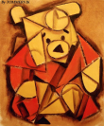  Cubism  Art movement of the early-20th-century  The movement was pioneered by Pablo Picasso and Georges Braque, joined by Jean Metzinger, Albert Gleizes, Robert Delaunay, Henri Le Fauconnier, and Fernand Léger. One primary influence that led to Cubism was the representation of three-dimensional form in the late works of Paul Cézanne.  Click on this link: Artworks and discover the various artists associated with the Cubism art movement.  Task: Create your own Art using various geometric shapes and write about which Cubism artist inspired you in creating your work of art.
Creative Writing
(English)

Similes and Metaphors
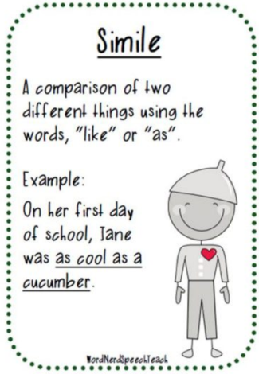
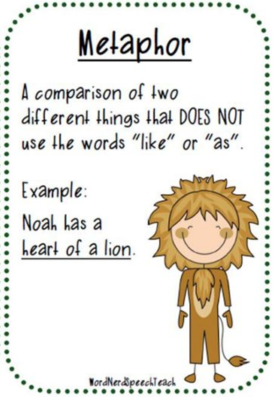

Write a description of yourself that includes at least 3 similes and 3 metaphors!
Science
Exploring the Physical Properties with your lunch!

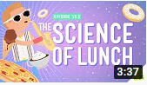
Click on this link: https://www.youtube.com/watch?v=dN2VDcmuTl4 and see how you can use your lunch to better understand the properties of matter.
Task: Compare the properties of some lunchtime items (as seen in the video) and make a poster demonstrating your understanding of the new vocabulary associated with the properties of matter.

Oral Communication
(Français)

Choisissez un épisode de:
Les héros du samedi
https://ici.radio-canada.ca/jeunesse/scolaire/emissions/5284/lesherosdusamedi/episodes/439256/sophie-bucher-soccer-foot-ballon/emission
- Quel épisode avez-vous choisi?
- Quelle est leur talent?
- Quel est ton talent?
- Fais un appel à un ami pour discuter l’épisode. N’oublies pas de parler en français!
Literacy Project
(multi-day)
Severe Weather Project
Choose a severe weather (tornadoes, hurricanes, blizzards, drought, flooding, dust storms/sandstorms, ice storms, tsunamis, typhoons) and complete a research project.

** See attachment for more detail **
Personal Wellness (English)
(multi-day)

OUTCOME: discuss the factors that may influence substance use or misuse
** Although the DARE program is no longer offered in Hampton schools, it continues to be available in Quispamsis/Rothesay. What better way to learn about the influence of substance abuse and misuse then from Cpl Daley of the Kennebecasis Regional Police Force who has been offering the program for many years.

https://m.youtube.com/watch?list=PLZCTzjFAsyd8-Nl4p-H3E1UESNsz34DMy&v=69KREDeMBE4
Science
STEAM Challenge!

Build a tower using only tinfoil. Document your process with photos or videos describing your methods, mistakes and successes! Finally, when it cannot be any taller, measure the height and share with your teacher!
