Writing  Write a letter to your Mom or another special lady in your life to tell her how much she means to you and how much you appreciate her. Draw some pictures to go with the letter or perhaps make a coupon book to go with it!  (attachment in email and on website for coupon book idea)  Écris une lettre à ta maman ou à une autre dame spéciale de ta vie pour lui dire comment qu’elle est spéciale à toi et combien tu l’apprécies. Dessine quelques images pour aller avec la lettre ou peut-être faire un carnet de coupons pour l’accompagner! | Reading Comprehension  Reading Comprehension: Visualizing  Visualizing refers to our ability to create pictures in our heads based on text we read or words we hear. We often revise our pictures as we read and learn new information.  Assignment: While you are reading today, pay close attention to the images that come to mind. Draw a detailed picture to represent what you visualized.  Reflection: How might visualizing help you understand what you are reading? | Literacy & Art  Get inspired by clicking on this link: https://www.artforkidshub.com/holiday-art-projects/mothers-day/  *Choose any of the art designs to help you create your unique Mother’s Day Card.  French immersion students may wish to write the message in the card in both French and English.  This card can be made for any special woman in your life – Mom, grandmother, aunt etc.
Science  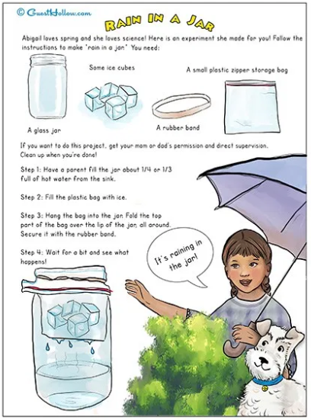  **If this document is too small, please have your child search for Rain in a Jar via google. | Oral Communication  (Français)  Regardez une vidéo des sœurs Coutu (en français) qui vous enseigne à propos d’une recette utilisant seulement 5 ingrédients.  https://ici.radio-canada.ca/jeunesse/scolaire/emissions/6543/le-defi-5-ingredients-avec-les-soeurs-coutu/episodes/455525/mousse-chocolat-dessert-recette-collation/emission  Imprimer ici/print here:  https://ici.radio-canada.ca/jeunesse/scolaire/emissions/6543/le-defi-5-ingredients-avec-les-soeurs-coutu/contenu/extras  Fais un appel à un ami et décrivez votre recette.  Quels ont été les défis? Qu'est-ce qui a été facile? | Science  Watch this video about  Chemical and Physical Changes: https://www.youtube.com/watch?v=x49BtB5dOwg  Divide a piece of paper into two sections. At the top of each section label with the titles: Chemical Changes vs Physical Changes. Find and draw objects that belong to these categories. By referring to the video above, include a list of clues to help you remember which category they belong.  Divisez un morceau de papier en deux sections. En haut de chaque section placer les titres : Changements chimiques vs Changements physiques. Recherchez et dessinez des objets appartenant à ces catégories. En vous référant à la vidéo ci-dessus, incluez une liste d'indices pour vous aider à vous rappeler à quelle catégorie ils appartiennent.
Personal Wellness (English)  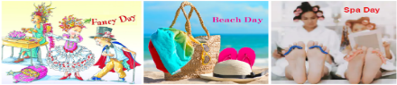  Encourage at least one other family member to participate in a ONE-Day ADVENTURE! Choose one of the following activities a write about your experience in your personal journal.  Fancy Day (Dress-up and have a dance or tea party.)  Beach Day (Gather all you need to go at the beach and have a fun day at your Beach House. Perhaps you could even have a picnic on the beach!)  Spa Day (Relax and enjoy all the things you would find at a real Spa).  Inspired by: Rhylee Gangon & Alice Kierstead | Creative writing  (English)  https://www.youtube.com/watch?v=N4RthqSOcR0  Watch this quick video that helps us understand how to “Show, Don’t Tell” the reader how our character feels. After watching the video, write 3 examples of your own, or choose 3 of the following sentences to improve!  She was cold.  He was scared.  She was excited.  They were hot. | Literacy Project  (multi-day)  Newspaper : Create a newspaper about a favorite book!  It must have a title and at least 2 articles:  - one factual article (ex: an article describing the book, the characters, setting, the events)  - one with your opinion about the book.  You can also include advertisements, weather reports, comic, or any other features found in a newspaper.  ** FI students are encouraged to complete this project in French. ☺

