Number Sense  Research a gummy bear recipe. List the ingredients needed to make the gummy bears, then double the recipe (so if it asks for 3 /4 ’s of a cup, you would double it to 1 1/ 2 cups).  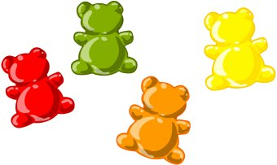 | Number Sense  How many $10 bills would it take to make $1 Million dollars?  Extension: Use newspapers and catalogues. Find items that you could buy to total $1 million. | Number Sense  Math Journal: In which of the following computations would you use the strategy of halving and doubling?  9 X 7  8 X 13  50 X 8  51 X 9  25 X 16  35 X 4  Explain your reasoning.
Math Online  Play math games on one or more of the websites listed below:  https://sso.prodigygame.com/login  https://happynumbers.com/  www.multiplication.com  https://mrnussbaum.com/place-value-pirates-online-game | Statistics & Probability  Tell whether you would use first-hand or second-hand data to answer the questions:  A) Do your friends watch more English or French videos?  B) Which foods contain the most vitamin C?  C) How many people live in Canada?  D) What are the favourite snack foods of the students at your school?  Extension: Brainstorm a list of your own questions that would be answered with first and second hand data. | Shape & Space  “Where I Live” Scavenger Hunt (see email attachment or button above)  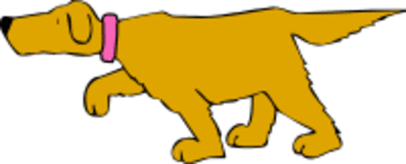
Patterns & Relations  Practice your grade five math skills online! Let’s work on algebra!  https://www.splashlearn.com/math-skills/fifth-grade/algebra/number-patterns--2?replace_all=1 | Math & Art  https://docs.google.com/presentation/d/  1wN1wKDVbFPbPB3yE43I35qzrXkUVf8tl/  edit#slide=id.p1  Enrichment: After completing your art portion, write two equivalent fractions for each fraction you used to make your fish. | Math & Science  (multi-day project)  STEAM Project :  Make a simple bird feeder out materials found around your house. Place it outside and record the number and types of birds you see this week. Share your findings with an adult. Discuss why people choose to put up bird feeders.  