Writing  Persuade me!  If you could have any class pet, what pet would you choose? Dog? Cat? Snake? Tarantula? Write a letter to your teacher naming the pet you would most like to have and give reasons why you should get to have this pet in class.  Persuade-moi !  Si tu peux avoir un animal de classe, quel animal choisirais-tu ? Chien ? Chat ? Serpent ? Tarentule ? Écris une lettre à ton enseignante en nommant l’animal que tu aimerais le plus et expliques pourquoi tu devrais avoir cet animal en classe. | Reading Comprehension  Have you ever listened to an interest book on audible.com? Choose a book that interest YOU and enjoy!  https://stories.audible.com/discovery  Reading Strategy:  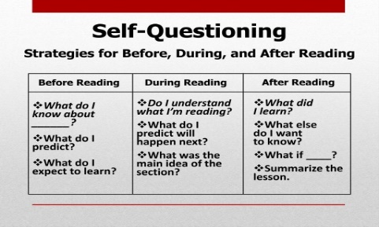  Write down questions that come to you as you read! Post-Its are a great tool for this. | Literacy & Art  (more than 30 mins)  Castles in the Middle Ages  https://drive.google.com/file/d/1YMeIz6k5pJPJNnww2h3MePRxBIgUymRj/view?usp=sharing  Extension: Which shapes did you use to create your castles? Why were castles significant in the Middle Ages? Is there a modern equivalent to the castle?
Literacy Project  (multi-day)  VIDEO GAME!  Come up with a plot for your own video game. You can be as creative as you’d like!  Your video game blurb must contain:  1) A summary (of at least 200 words) of the plot of your video game that includes the setting.  2) Summary of abilities and what you can do.  3) List of at three game features.  Create a cover for your video game. You can use images from online resources or draw. Your cover needs to be neat and portray the plot of your game accurately. Above all, you want someone to purchase your game based on your cover and blurb!  ** Inspired by Michael Hughes** | French Oral Communication  Play a videogame while practicing speaking French!  (parent and student requested):  Reserve a block of time each week to play a videogame with your friends and practice speaking French.  Jouer à un jeu vidéo en parlant en français  (Demandés par les parents et élèves):  Réservez un bloc de temps chaque semaine pour jouer à un jeu vidéo avec vos ami(e)s et parler en français. | Science  Why not find a Science experiment to try at home! Be sure that your parents are ok with the experiment chosen!  https://www.stevespanglerscience.com  /lab/experiments/soda-bottle-tornado/  Choisis une expérience de Science que  tu peux faire à la maison! Demande à tes parents avant s’ils sont d’accord avec l’expérience que tu as choisis!
Personal Wellness (English)  Check out Mrs. Henry’s website on wellness & physical activity! There are lots of activities there to consider. Take a picture of yourself doing one of the activities and send it to Mrs. Henry! She will add pictures of students keeping active on her website each week.  https://hamptonelementarype.  weebly.com/ | Creative writing  (English)  Nature Scavenger Hunt  (see attachment in email or button above)  Once hunt is complete, write a poem or paragraph about what you saw, smelled, heard and felt. | Science  Museum of the World  https://britishmuseum.withgoogle.com/  * Choose an artifact. Tell us what it is, why you find it interesting and where it was found.  * Choisis un artefact. Dites pourquoi vous le trouvez intéressant et où c’était découvrir.

