Number Sense  Investigation: Find your true age!  How many years old are you?  How many months old are you?  How many days old are you?  How many hours old are you?  How many minutes old are you? | Number Sense  Create five "Fraction Hero" trading cards. The hero can be any real life or a make-believe person that you think is a hero. On the front of each card, write their name and illustrate their picture. On the back, write two fraction fiction facts about your hero. Each fraction should have two different denominators. Ex: Jackie Robinson was very good at baseball as he could cover 2/3 of the baseball field. Jackie Robinson played baseball 3/5 of his life. | Number Sense  Research the population of each province and territory in Canada. Write them down in order from greatest to least.  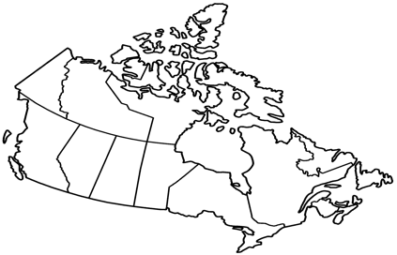
Math Online  Play math games on one of the following websites:  https://sso.prodigygame.com/login (using username and password from agendas)  https://www.visualfractions.com/Games.htm  https://happynumbers.com/ (see teacher for username/ password | Statistics & Probability  Join us for some probability games on https://mrnussbaum.com/probability-fair-online-game | Shape & Space  Draw 1 millimetre, 1 centimetre, and 1 metre on a piece of paper. Brainstorm a list of objects that would be 1 mm, cm, and 1 m.
Patterns & Relations  Math Journal:  Carter says that the W in the equation 16= w – 4 equals 12. Is he correct? What is the purpose of the letter variable in the equation? Create 3 more equations where 12 could be the answer for a variable. | Math & Art  Make your own ART creation and calculated the fractions that represents each colour. Puff paint ingredients: 1 cup of flour 1 cup of salt 1 cup of water. Mix well, divide into separate small dishes add a few drops of different food colouring to each. Mix well. Place in squeeze bottles if available (or used empty shampoo and condition bottles). It also works well just from the dish with paintbrushes as well. It is best to use heavy paper or cardboard. | Math & Science  (multi-day project)  STEM project – make a paper horse that walks on its own!  https://frugalfun4boys.com/paper-horse-that-walks/  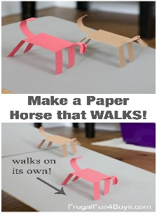
*** Just a reminder to parents that, as directed by the province, we are not permitted to assess and evaluate your child’s work. In saying this, we are more than happy to see what they are doing at home! We do appreciate the emails and pictures we get that demonstrate what is done at home for online learning. Keep up the great work! ***

