Writing  It’s hard to believe that another school year is almost over! Write a thank you letter to a teacher or any other adult at HES who you appreciate and who has helped you grow throughout your years at HES. Be sure to send them your letter via email or mail (can mail to HES with that adult’s name on it). | Reading Comprehension  Can you imagine a life without our warm summer sun? Create an appreciation for this simple luxury by reading/ listening to the short story “All Summer in a Day” by Ray Bradbury.  http://readlifelong.weebly.com/all-summer-in-a-day.html  Complete the corresponding comprehension questions and coloring activity found linked in the email.  **See attachment** | Literacy & Art  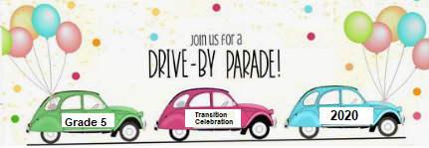  Task: Make at least one poster to help decorate your car for the Grade 5 Drive thru Celebration at HES on Wed June 10th.  Feel free to add as many decorations on your car including balloons and streamers.
Literacy Project  (multi-day)  Complete a Year End Memory Book for the 2019/2020 school year!  Memory book is in PowerPoint formation so you can edit the document on your device and print after completed!  **See attachment ‘Week 9 Editable Year End Memory Book’ | Oral Communication (français)  Une discussion sur votre année scolaire 2019/2020  Complètes les phrases suivantes puis discutes avec un ami!  - Les 5 souvenirs que je ne vais pas oublié sont...  - Mon sujet préféré est...  - Mon souvenir le plus drôle est... (Où? Quand? Avec qui? Ce qui s’est passé?)  - Cet été je voudrais...  - 5 choses que j’ai apprises cette année sont...  - Le projet que j’ai aimé le plus est...  - L’année prochaine je vais améliorer... | Summertime Word Search  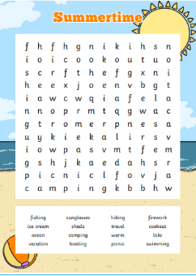  Task: Find all the Summertime related words indicated in the list. Write a paragraph using all the words in anticipation for all the Summer fun activities.  *** Please see attachment entitled: Wk_10_Summertime Word Search ***
Personal Wellness (English)  Produce a TV commercial!! Create your own healthy breakfast cereal. Be creative! Create the packaging and a TV commercial ‘pitch’ to go along with it. Be sure to record your commercial! Send it off to your teacher so she can see it too! | Creative Writing  My Future’s So Bright  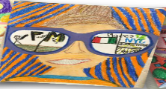  We know all of your future’s are bright and we want to know what you believe will be in yours!  Draw a self-portrait wearing sunglasses and in the reflection of the lens, draw what you believe will be in your future. This could be an event, a goal, a dream or an activity!  Attached in the email is a PDF with a template of sunglasses, and a page for you to describe what your predictions for your future are! ** See Attachment | Science  Find a science experiment online or in a book that you would like to try.  With the support of your parents, conduct your experiment and share the results with your teachers by creating a video, poster or a written description!  Here is a fantastic resource to help inspire your creativity!  http://www.sciencefun.org/kidszone/experiments/

