Number Sense  Create a LEGO maze and write a code on how to get through it. (EX: Go forward 3 cm. Turn left 9 cm, advance 2 cm) Now change your code to mm. What are your measurements in mm?  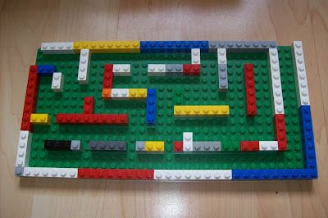 | Number Sense  Look around your house and find 5 decimals (ex. Decimals can be found in flyers, catalogues, newspapers). Once you have found the 5 decimals, do the following:  - Place them in order from lowest to greatest.  - Add the two largest decimals to find the sum.  - Subtract the smallest decimal from the largest decimal to find the difference.  - Add them all together! ☺ | Number Sense  Division Problem  Problem: Michael builds a string of beads using 3 colours, starting at white, black, then red then repeating the pattern.  He continues building using 103 beads altogether. What colour is the last bead?  Find the colour of the last bead if there are these numbers of beads:  2398, 4712, 34 567, 90 876
Shape & Space
Shape Walk Adventure:
In this activity, you will be going on a walk to look at objects in nature. Use a blank piece of paper to record your observations.
The world around us is composed of many different shapes. Sometimes these shapes are put together to make more complex designs. Nature also is composed of shapes and designs. Sometimes the designs and patterns serve a purpose, or are an adaptation; at other times they may be aesthetic. Think about the needles on a conifer or pine tree. Why are they long and thin?
Compare this to the shape of a maple leaf, which would have much more surface area, curves and points. What purpose does the broad leaf have for the Maple tree? Grass is made of an elongated leaf with parallel lines running through this. What purpose do the parallel lines serve for the plant?
What to do:
1. As you walk, look for shapes that can be found in the “Shape Attributes Chart” (attached)
Math Online  Play math games on one or more of the websites listed below:  https://sso.prodigygame.com/login  https://happynumbers.com/  www.multiplication.com | Patterns & Relations  The architect got really carried away with this sequence of buildings. But try to answer the questions anyway.  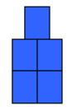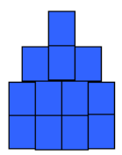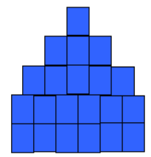  How many blue squares do we need for the first building? The second? The third? How many blue squares will we need for the sixth building? The eighth? How does the pattern grow as we go from building to building? What is the number of the building if we have to use exactly 77 blue squares to make it? Which of these numbers are not a number of squares for one of these buildings: 140, 141, 142, 143? What is the largest number of squares less than 130 in this pattern? Which two buildings have 200 squares between them? (Is there more than one answer for this question?) What is the general rule for this pattern? That is, given the number of the building, can you make up a rule that gives the number of the squares? Can you see any more patterns here?
Statistics & Probability
1) Describe each event using these words: possible, impossible, certain, unlikely, likely
a) It will rain meatballs this summer. ____
b) We will eat pizza this week. _____
c) You will walk on the moon. ______
2) Draw a picture of a paper bag with counters inside where:
a) Picking a red counter is likely.
b) Picking a blue counter is unlikely.
c) Picking an orange counter is impossible.
Math & Art:
Watch the video & listen to the Song about Parallel, Perpendicular and Intersecting Lines: https://www.youtube.com/watch?v=P3AOoLbA3us
Watch the 2nd video and Listen to the Song about Horizontal and Vertical lines among others:
https://www.youtube.com/watch?v=DQEVllmeWH4
Enrichment: Students are encouraged to look around and find as many lines around the house. They should draw the objects and name each type of line in their drawing.
Math & Science
Watch a video about a property of matter: pH https://www.youtube.com/watch?v=I18K2upEHLc
Note: Parent supervision is required for this experiment!
The experiment investigates the question: Can you determine the pH of a substance by using a Red Cabbage pH Acid Base Indicator?

Enrichment: Students are encouraged to do this experiment and estimate the pH of each substance based on the colour that corresponds to the pH Scale. Students can also do an internet search to check out the actual pH of each substance.

