Literacy Menu
April 14-17
Choose 1 literacy activity per school day.
Write a journal entry.  IDEA/IDÉE  Think about our amazing planet Earth. Write about some different ways that we can help protect our planet.  Pensez à notre incroyable planète Terre. Écrivez à propos de différentes façons dont nous pouvons aider à protéger notre planète. | Razkids.com  - If student is unsure of login, please email for information.  - Read a book and answer the comprehension questions that go along with the text. You’ve got this! | NB Public library / bibliothèque publique du NB:  https://nbpl.ent.sirsidynix.net/client/fr_CA/default/  - Audio books: Listen to a book and draw a picture that would go along with the book you listened to. Write a few sentences along with the picture to summarize the book.
PROJECT (ongoing choice for a couple of weeks):  Time capsule: (attachment included on email – available in both French and English). | Oral  Make a phone call to a friend/Fais un appel a un ami.  ** Les amis des classes d’immersion peuvent parler en français! | Science:  States of Matter Game:  https://www.abcya.com/games/states_of_matter
*** Immersion students are encouraged to do all or most of these activities in French. ☺
** ** Les amis des classes d'immersion peuvent écrire en français. Lorsque vous avez terminé, utilisez bonpatron.com pour vérifier votre travail.
NB Public Library:
Know all your children’s books by heart? Need a change? Animated picture books are available online, in multiple languages, through TumbleBooks. Go to https://www2.gnb.ca/…/nb…/collections/content/databases.html
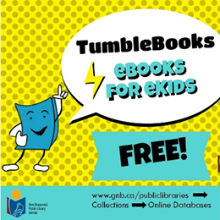

Already read the same book twice this week? Get some fresh reads at https://www2.gnb.ca/…/g…/en/departments/nbpl/electronic.html and download eBooks or audiobooks from your public library.
