Number Sense  Can you escape?  Oh my! A mad mathematician locked your entire class in the classroom on the last day of school! Oh la la!! In order to escape and enjoy your summer, you MUST use your multiplication skills to convince him to let you go. Answer the questions at each level! Once all levels are complete, retrieve the completion code to save the day for you and your peers! You must hurry! Do you want to be trapped in math class ALL summer? ☺  Good luck everyone! If you need to complete this activity with a friend, please ask for help! Calling a friend for help is OK!!  Digital Link: http://bit.ly/2TraE7n | Number Sense  Research the number of days per school year that students attend school in two different countries. Record the name of the countries you researched and the number of days, hours and minutes that students in each country attend school. In which country would you rather attend school? | Number Sense  Record-breakers: Use a stopwatch to time yourself running, roller blading, swimming, or biking. Then try to beat your time. Be sure to keep the distance you’re moving the same for each trial. Graph the results. (You may need a partner for this.)  More challenges:  How many times can you bounce the basketball in one minute?  How many jumping jacks can you do in one minute?  How many laps around your house can you do in one, two, three minutes?  Be sure to redo each activity and try to beat your score each time!  Create your own challenge!
Math & Social Distancing  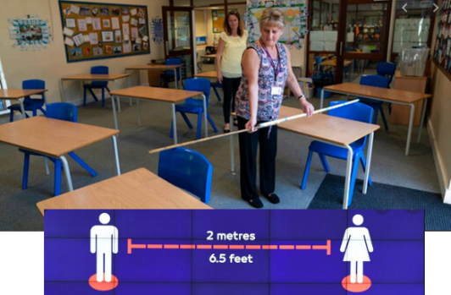  If 30 people needed to meet at one time, how big of an area would you need a room to be to respect the social distancing norms of 2 meters between individuals?  Enrichment activity: Convert your answer in feet. Remember 2 meters = 6.5 feet. | Math Online  https://www.mathplayground.com/  index_fractions.html  www.prodigy.com  https://www.mrnussbaum.com/  placevaluepirates | Shape & Space  Practice identifying quadrilaterals. Use the ‘Hint’ button for a review.  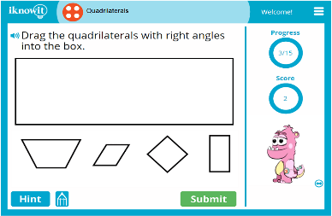  https://www.iknowit.com/lessons/d-geometry-quadrilaterals.html
Math & Art  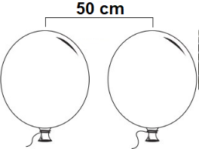  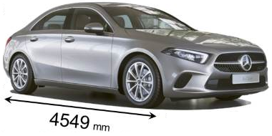  Task: Calculate how many balloons you would need on each side of your car. You want the balloons to be separated by 50 cm and your car’s length is 4549 mm.  Remember: 10mm = 1 cm | Patterns & Relations  Practice Order of Operations (PEDMAS) on Khan Academy. Don’t forget that anything in parenthesis (brackets) must be done first.  https://www.khanacademy.org/math/cc-fifth-grade-math/imp-algebraic-thinking | Statistics & Probability  Test out your probability skills by learning to play the game of SKUNK and playing it at home with a family member.  http://mathwire.com/games/skunk.pdf  https://www.youtube.com/watch?v=5JlZ5usFJcA

