Math & Art
Watch this video about the Introduction to Transformations: https://www.khanacademy.org/math/basic-geo/basic-geo-transformations-congruence/transformations-intro-basic-geo/v/introduction-to-transformations

The Art of Transformations:
Perform a single transformation (translation, rotation, and reflection) of 2-D shape and draw the image.

Example of each type of transformation:
• The yellow dotes and blue quadrilateral (image) have undergone a translation because the orientation remains the same. (They simply slide from one place to the next):
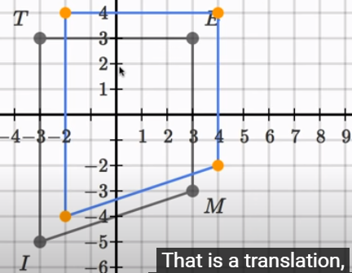

• Relative to that yellow point the blue quadrilateral (image) has undergone a 90⁰ rotation counterclockwise:
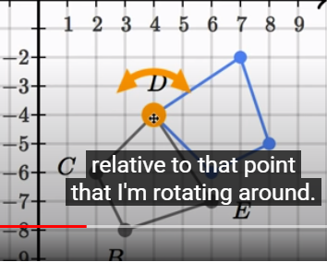

• The blue irregular pentagon (image) is an example of a reﬂection because the black image is reflected across a line (just like the image in a mirror):
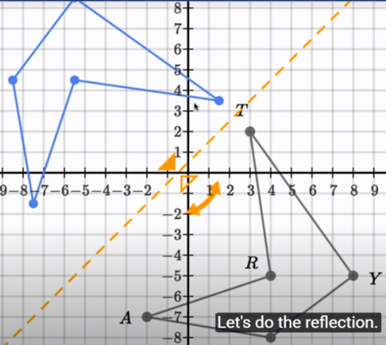

This art project is inspired by a quilted square pattern.

Task:
This week you will be trying your hand at this traditional art form. You will design and draw a quilt block pattern using a combination of squares, rectangles, triangles and/or other shapes of your choice. Your block should use at least 3 different colours.

Note: Using graph paper or creating your own squares on a piece of paper will make this activity much easier.

An example of a quilt block pattern: An example of an overall design of the quilt:
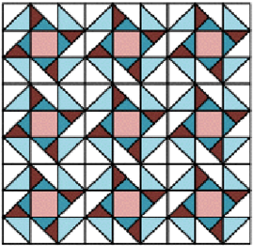
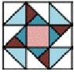

Design Challenge:
Now it’s your turn to design your own quilted block pattern that you will repeat on the entire grid paper. Your quilt design needs to demonstrate:

•A quilted block pattern design that is transformed to create visual appeal to the overall design of the quilt.

•At least 1translation demonstrated in the quilted square and overall design of the quilt.

•At least 1reﬂection demonstrated in the quilted square and overall design of the quilt.

•At least 1rotation demonstrated in the quilted square and overall design of the quilt.

Simplified version:
Art project using a quilted square pattern.
Note: This art project can also be simplified by using different coloured construction paper and cutting out the same shapes and sizes to create a single quilt block pattern. Don’t forget to include the three types of transformations. Once you are happy with the pattern you can create the overall design of the quilt.

