Lesson – Making Ice Cream This lesson focuses on both chemical and physical changes.
First, a non-reversible chemical change occurs as students add sugar and vanilla to the milk. | 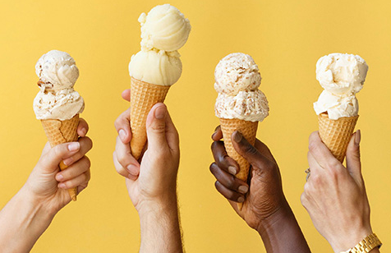  Third… Science never tasted so good! | Second, a reversible physical change occurs as the students turn the liquid into a semi-solid.
Materials: Milk, sugar, vanilla, small Ziploc bags, large Ziploc bags, ice, salt… https://www.sciencebuddies.org/stem-activities/ice-cream-bag#materials | 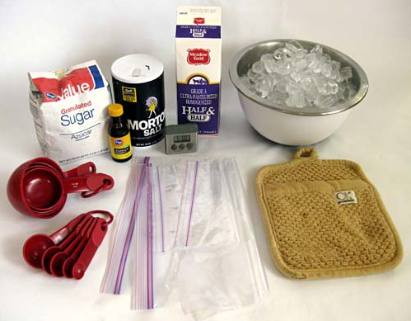 | Making Ice Cream instructions: https://www.sciencebuddies.org/stem-activities/ice-cream-bag#instructions
Procedure:
* Remind students to be thinking about both chemical and physical changes to matter and the reversible and non-reversible properties of each of those.
* Once the students have completed the instructions have them EAT their ice cream while discussing the chemical and physical properties that they manipulated.
* Use the diagram on the other following to help better define a Physical and Chemical change. Think about what happened in this “Ice Cream Experiment”. (FI students may wish to write their answers in French)
Definition /Définition :  Physical Change /  Changement physique | Characteristics / Caractéristiques : | Definition /Définition :  Chemical Change /  Changement chimique | Characteristics / Caractéristiques :
Examples / Exemples : | Counterexamples/  Non-exemples: | Examples / Exemples : | Counterexamples/  Non-exemples:
Note: For more information about the chemical aspects of ice cream please see the following video: https://www.youtube.com/watch?v=-rlapUkWCSM

