Number Sense  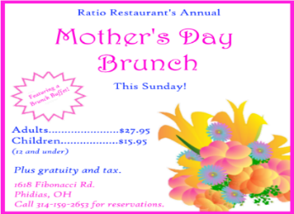  Pretend that you want to take your mother, aunt, grandmother, or any other special friend or family member out for Mother’s Day.  Make a list of the people who will be eating brunch, including you. How much would it cost your family to eat at this restaurant?  Write an expression that can be used to determine the cost for a adults and c children to eat brunch at this restaurant. | Number Sense  *Challenge yourself*  1. Roll to create a 6-digit number.  2. Label each place value.  3. Write the number in word form and expanded form.  4. Round this number to the nearest thousand.  5. What is the value of the digit in the hundreds place?  6. What is the largest number you can make with your numbers?  7. What is double your number?  8. What is half of your number?  9. Read your number to a family member (in French too).  10. What is your number plus  10 000? | Number Sense  Strategy Journal: Create a journal with 4 pages (one for addition, one for subtraction, one for multiplication and one for division).  Write all the strategies you know for adding, subtracting, multiplying and dividing.  If you need help for some strategies, like long division, ask a friend, parent, or contact your teacher! 😊
Shape & Space
Find and take pictures quadrilaterals. Some will fall into more than one category. Make sure you have six DIFFERENT pictures – one for each of the quadrilaterals listed.
1. Square
2. Rectangle
3. Rhombus - A flat shape with 4 straight sides that are all equal length.
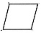
4. Parallelogram - A Parallelogram is a flat shape with opposite sides parallel and equal in length.
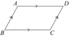
5. Trapezoid - a quadrilateral with only one pair of parallel sides.
6. Quadrilateral (all 4 sided shapes)
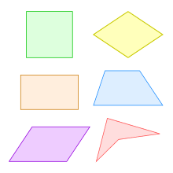
Submit your photos to your teacher. Make sure they have labelled properly.

Math Online
Play math games on one or more of the websites listed below:
https://sso.prodigygame.com/login
https://happynumbers.com/
www.multiplication.com

Math & Science
(multi-day experiment)
Watch a video about one of the Properties of Matter: Density

The experiment investigates the question: Does changing the amount of material change whether an object sinks or floats?

https://www.youtube.com/watch?v=C5oPI5iI-Kg

Enrichment: Students are encouraged to do this experiment and calculate the density of the clay (Playdough) versus a small wooden block.
The density can be calculated by using this formula: D = M ÷ V D = Density M = Mass in grams and V is the volume in mL.

Remember the volume of a cube: V = Length x Height x Width Also, remember: 1 cm3 = 1 m

Patterns & Relations
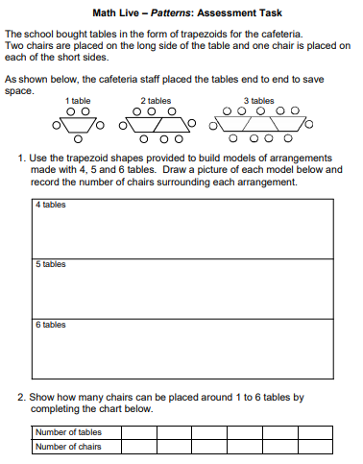
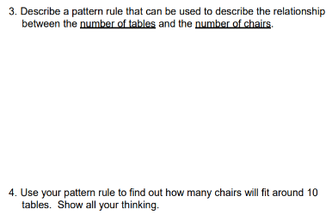

http://www.learnalberta.ca/content/me5l/html/
lessons/11/notes/m5_patterns_assessment.pdf (pages 3 and 4)
Math & Art
Create Geometric Shapes with Homemade Playdough
Quadrilateral properties: https://www.khanacademy.org/math/cc-fifth-grade-math/properties-of-shapes/imp-quadrilaterals-2/v/quadrilateral-properties?modal=1
Enrichment: Combine several geometric shapes into a unique creature or work of art! Make sure you name each different type of geometric shape.

Statistics & Probability
This table shows the results of a survey. Display these data in a bar graph. Trees Planted
Type of Tree | April
Maple | 200
Elm | 125
Oak | 175
Pine | 150

